SyncFlow AI
AI-Powered Startup Collaboration Dashboard

Business Analysis Documentation

Prepared By:
Mohammad Thoufiq

Role:
Business Analyst Intern

Date:
May 2026

Table of Contents

1. Project Overview

2. Business Problem

3. Project Objectives

4. Modules / Features

5. User Roles

6. User Stories

7. Functional Requirements

8. Non-Functional Requirements

9. Agile Workflow

10. Tools Used

11. Conclusion

📌 1. PROJECT OVERVIEW
SyncFlow AI is an AI-powered SaaS collaboration platform designed to improve productivity, project tracking, team communication, and workflow visibility for startup teams.

The platform combines features inspired by modern collaboration tools such as Jira, Notion, Slack, and Linear into a centralized dashboard system.

The objective of the platform is to streamline startup operations through task management, sprint workflows, analytics, team collaboration, and productivity monitoring.

The system is designed for startup teams, project managers, developers, QA teams, and business stakeholders.

📌 2. BUSINESS PROBLEM
Modern startup teams often face challenges related to:

- Poor task visibility
- Inefficient team communication
- Lack of centralized collaboration
- Difficulty tracking sprint progress
- Limited workflow analytics
- Delayed project delivery

Existing tools often require multiple platforms to manage communication, project tracking, and reporting.

SyncFlow AI aims to solve these challenges by providing an all-in-one collaboration dashboard.

📌 3. PROJECT OBJECTIVES
The primary objectives of SyncFlow AI are:

- Improve collaboration among startup teams
- Centralize project and sprint management
- Enable real-time productivity tracking
- Provide workflow analytics and reporting
- Simplify task assignment and monitoring
- Improve sprint visibility for stakeholders
- Enhance communication between departments

📌 4. MODULES / FEATURES
The platform includes the following modules:

1. User Authentication
- Login
- Secure authentication
- User session management

2. Dashboard
- Sprint overview
- Team activity
- Productivity metrics
- Upcoming events

3. Kanban Board
- Task management
- Status tracking
- Sprint workflows

4. Team Workspace
- Team collaboration
- Shared updates
- Activity feeds

5. Analytics Dashboard
- Productivity reports
- Sprint performance
- Workflow insights

6. Calendar & Scheduling
- Sprint schedules
- Meetings
- Deadlines

7. Notification System
- Task updates
- Alerts
- Team notifications

📌 5. USER ROLES
The system contains the following user roles:

1. Admin
- Manage platform settings
- Manage users
- Access analytics

2. Project Manager
- Create sprints
- Assign tasks
- Monitor project progress

3. Team Member
- View assigned tasks
- Update task status
- Collaborate with team

4. QA Team
- Test completed tasks
- Report defects
- Verify fixes

📌 6. USER STORIES
1. As a project manager,
I want to assign tasks to team members,
So that project activities can be tracked efficiently.

2. As a developer,
I want to update task status,
So that sprint progress remains visible.

3. As a team member,
I want to collaborate within a shared workspace,
So that communication becomes easier.

4. As an admin,
I want to monitor productivity analytics,
So that workflow performance can be improved.

5. As a QA engineer,
I want to report bugs during testing,
So that issues can be resolved before deployment.

📌 7. FUNCTIONAL REQUIREMENTS
FR-001:
The system shall allow users to securely log in.

FR-002:
The dashboard shall display sprint and project summaries.

FR-003:
The system shall allow project managers to assign tasks.

FR-004:
The Kanban board shall display task statuses.

FR-005:
The system shall provide notification alerts.

FR-006:
The analytics module shall display productivity reports.

FR-007:
The calendar module shall manage schedules and deadlines.

FR-008:
The system shall support team collaboration workspaces.

📌 8. NON-FUNCTIONAL REQUIREMENTS
- The system should support responsive UI design.
- The platform should load within acceptable response time.
- User data should be securely managed.
- The system should support multiple concurrent users.
- The dashboard should provide high usability and accessibility.

📌 9. AGILE WORKFLOW USED
The project follows Agile Scrum methodology.

Workflow Stages:
- Requirement Gathering
- Business Analysis
- Sprint Planning
- Task Assignment
- Development
- Testing
- Sprint Review
- Client Feedback
- Deployment

📌 10. TOOLS USED
- Lucidchart
- Uizard AI
- ChatGPT
- Agile Scrum Methodology
- SaaS Dashboard Concepts

📌 11. CONCLUSION
SyncFlow AI demonstrates the integration of Business Analysis concepts, Agile workflows, AI-assisted UI generation, and SaaS product design.

The project helped explore modern startup collaboration systems while improving understanding of workflow management, sprint tracking, and product documentation.

UI Wireframes & Workflow Screens
- Workflow screenshot
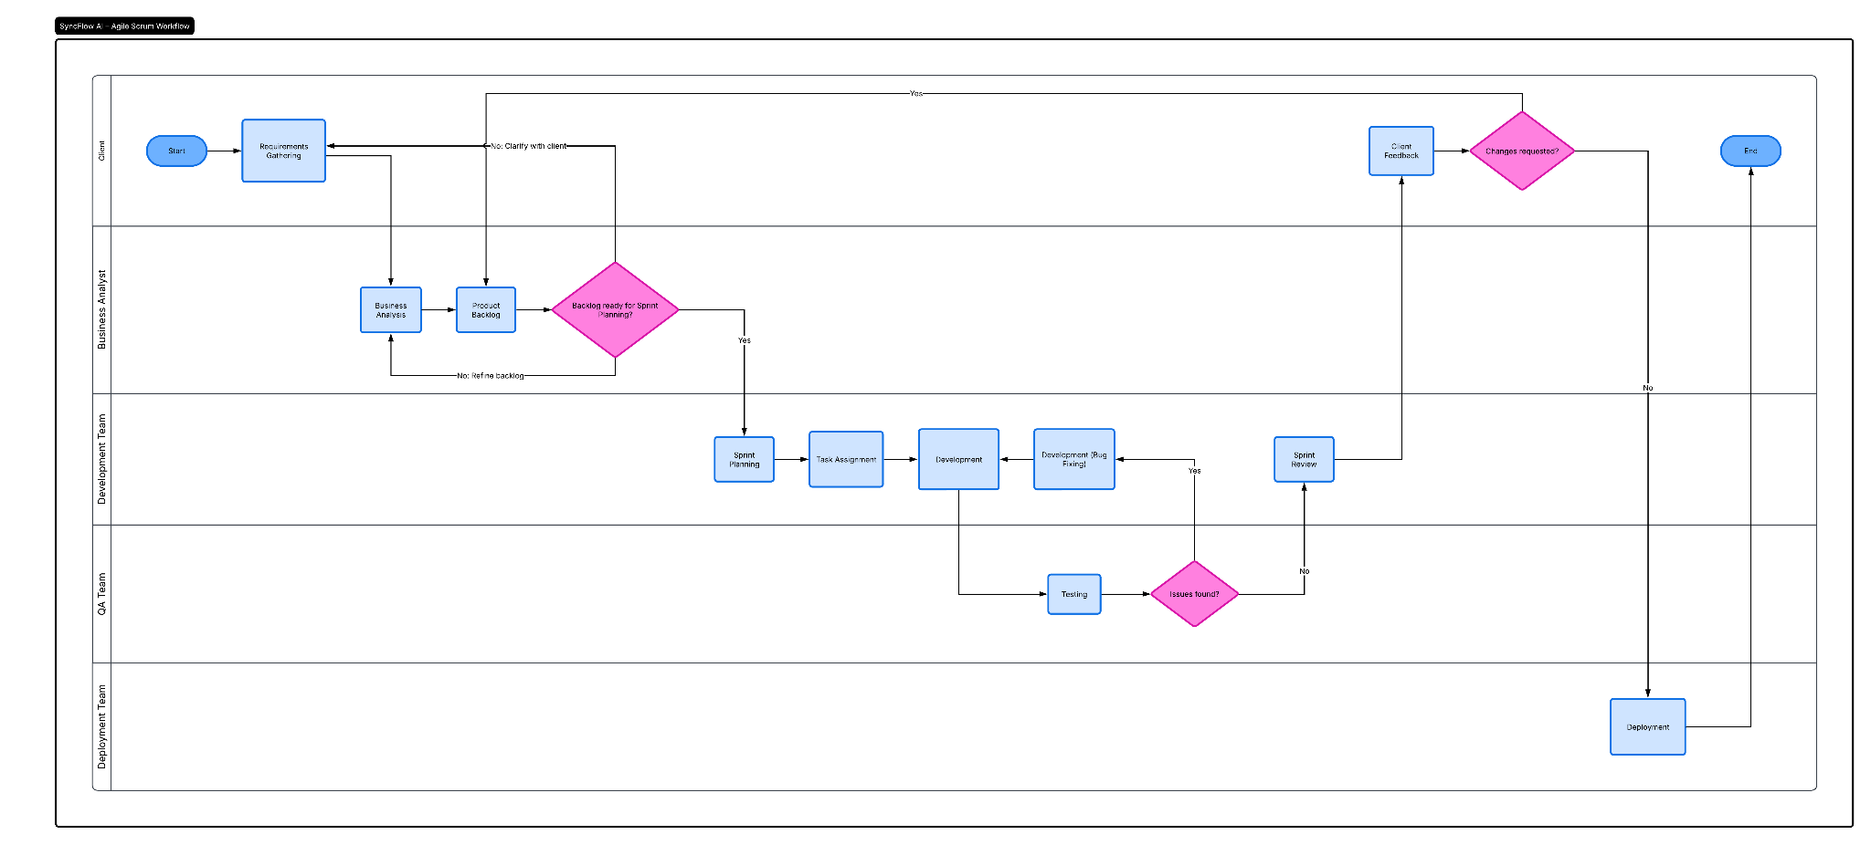
- Dashboard screenshots
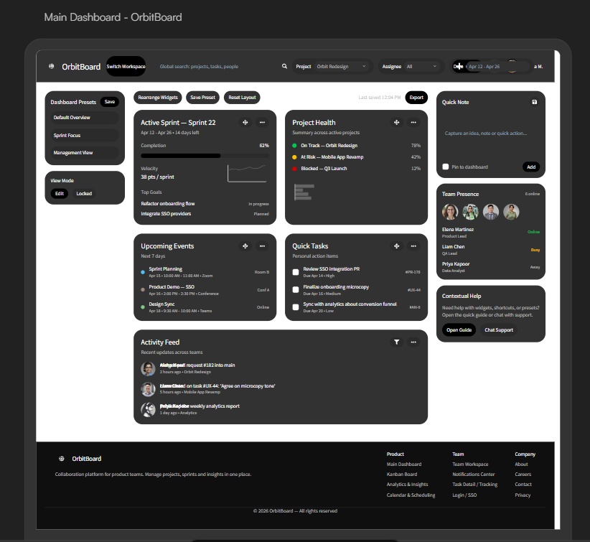
- Kanban screenshot
